# **INTERNAL 2**

# 

Name : Sejal Pawar

Class : Msc . Computer science ( Part 1 )

Rollno : 504

Subject : AES (Embedded System)

Topic : Tinkercad multiple componets functioning through keypad

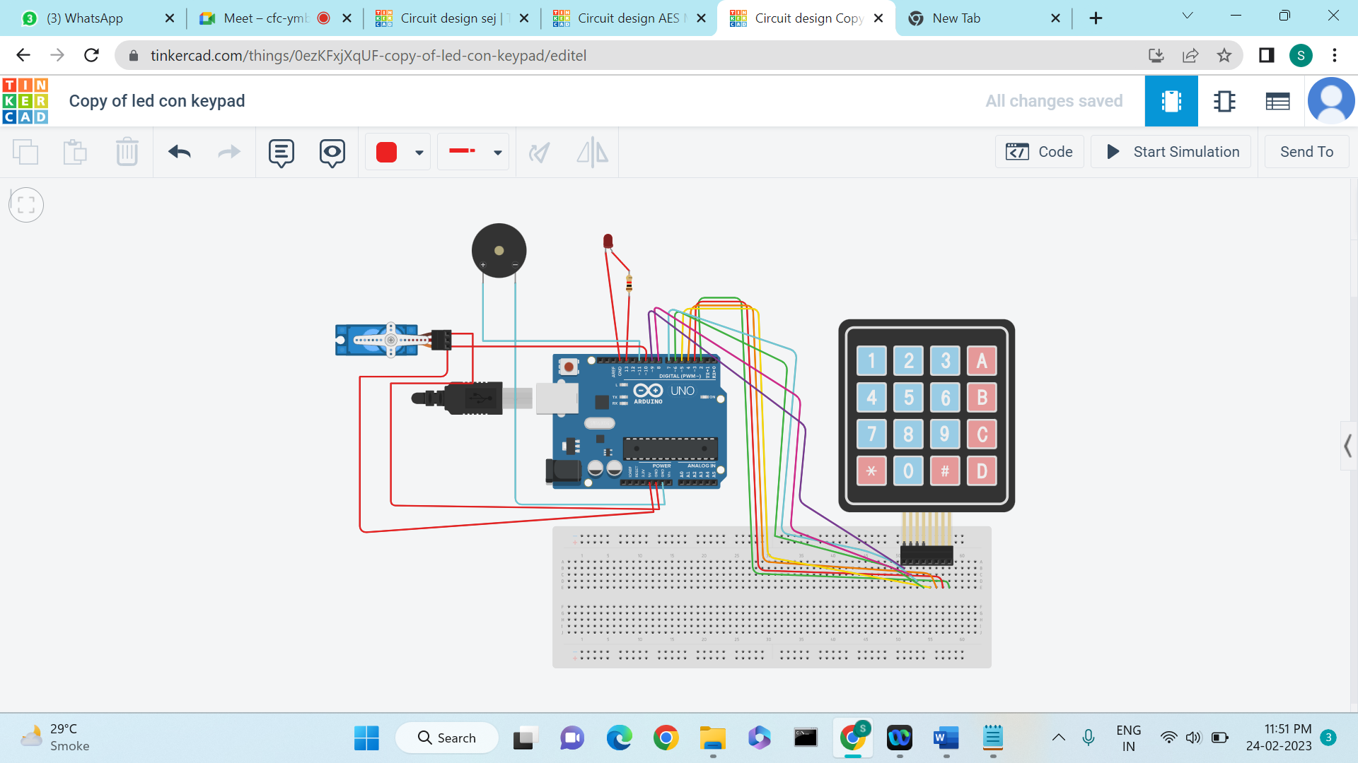

# **Components Used :**

Keypad

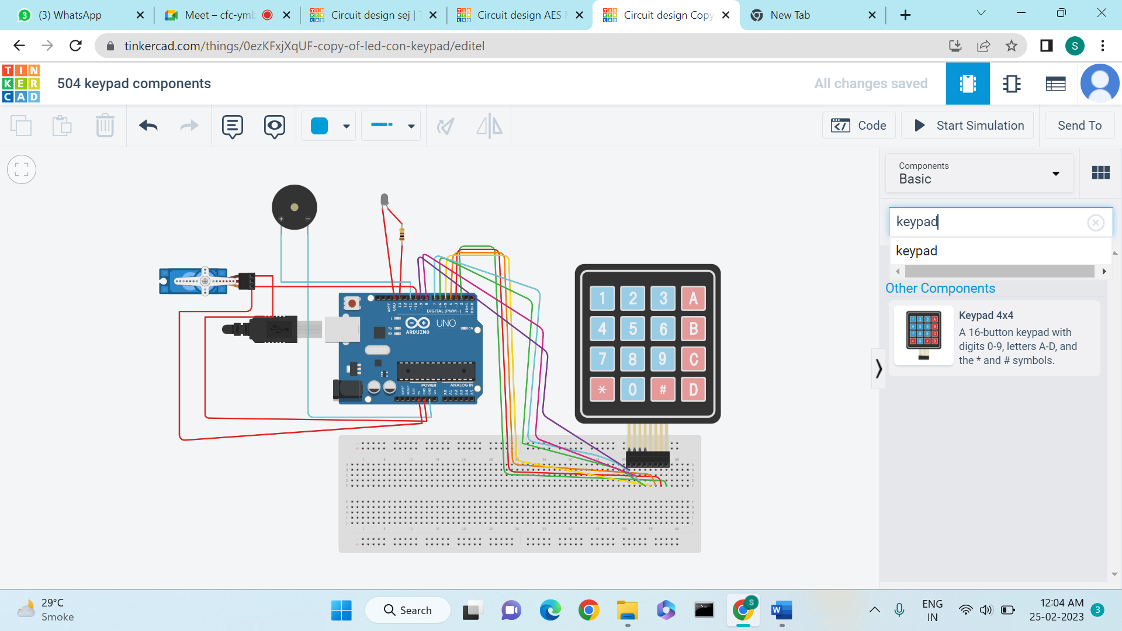

The keypad **allows an individual to quickly input numbers into a computer**. For example, the keypad is often used for anyone who deals with numbers frequently or has to perform calculations with a software calculator. To switch between the number and the directional functions of the keypad, press the Num Lock key.

Piezo

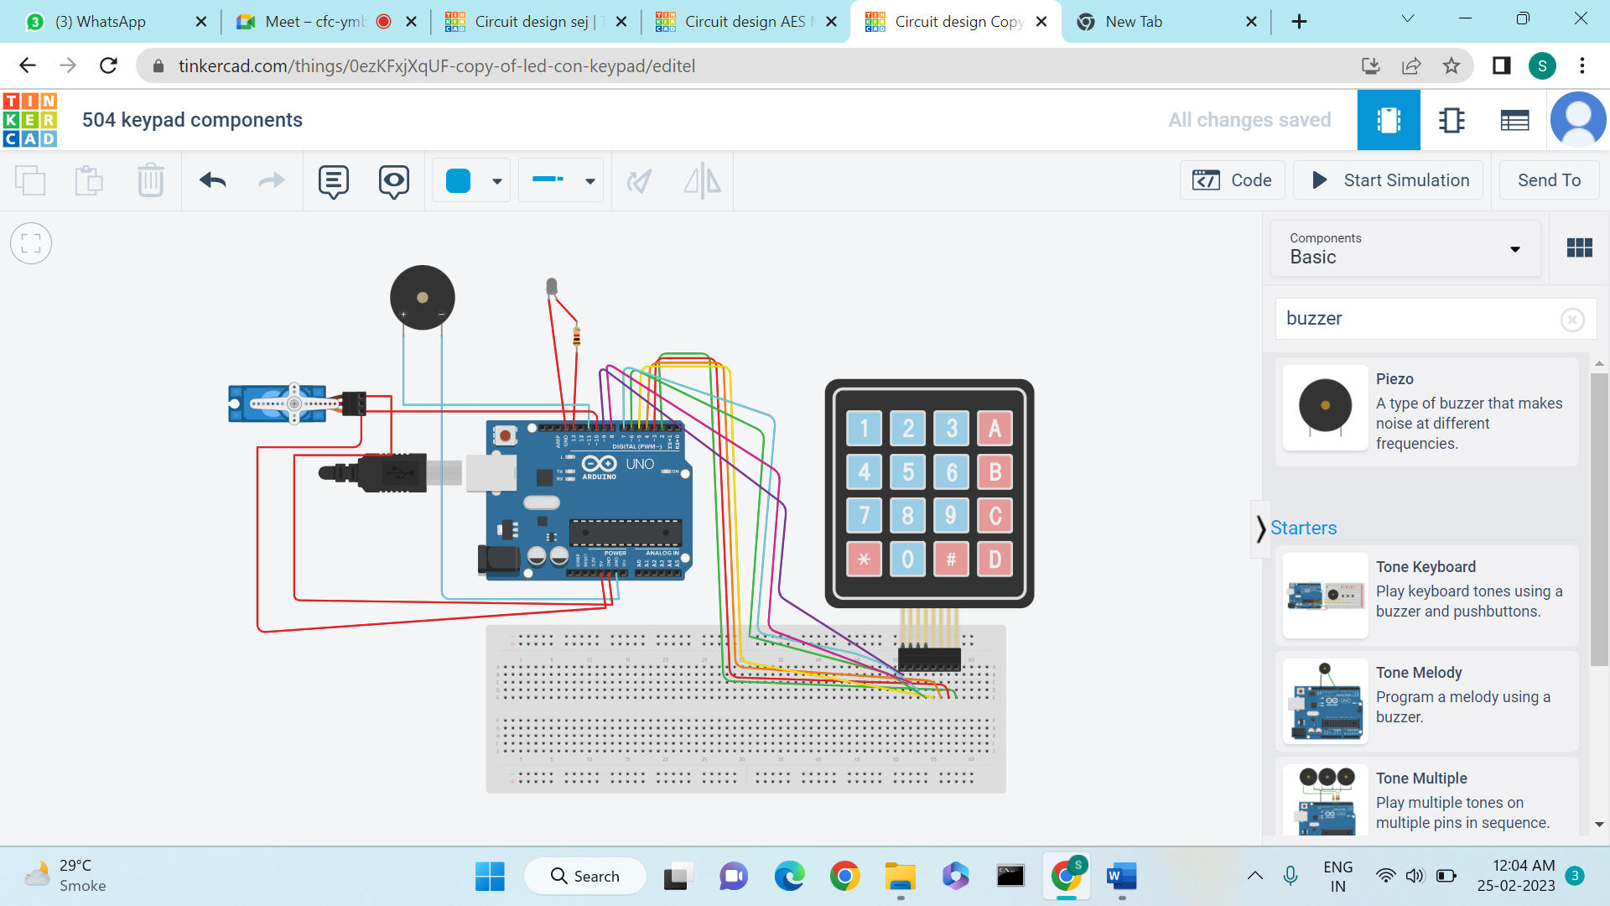

It's simple, **tone(buzzer, 1000) sends a 1KHz sound signal to pin 9, delay(1000) pause the program for one second and noTone(buzzer) stops the signal sound**. The loop() routine will make this run again and again making a short beeping sound.

Servo Motor

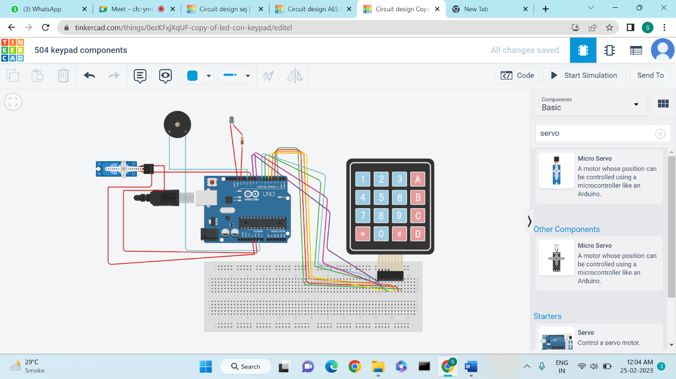

Servo motors or “servos”, as they are known, are electronic devices and rotary or linear actuators that rotate and push parts of a machine with precision. Servos are **mainly used on angular or linear position and for specific velocity, and acceleration**.

BreadBoard

A breadboard is a**rectangular plastic board** with a bunch of tiny holes in it. These holes let you easily insert electronic components to prototype (meaning to build and test an early version of) an electronic circuit, like this one with a battery, switch, resistor, and an LED (light-emitting diode).

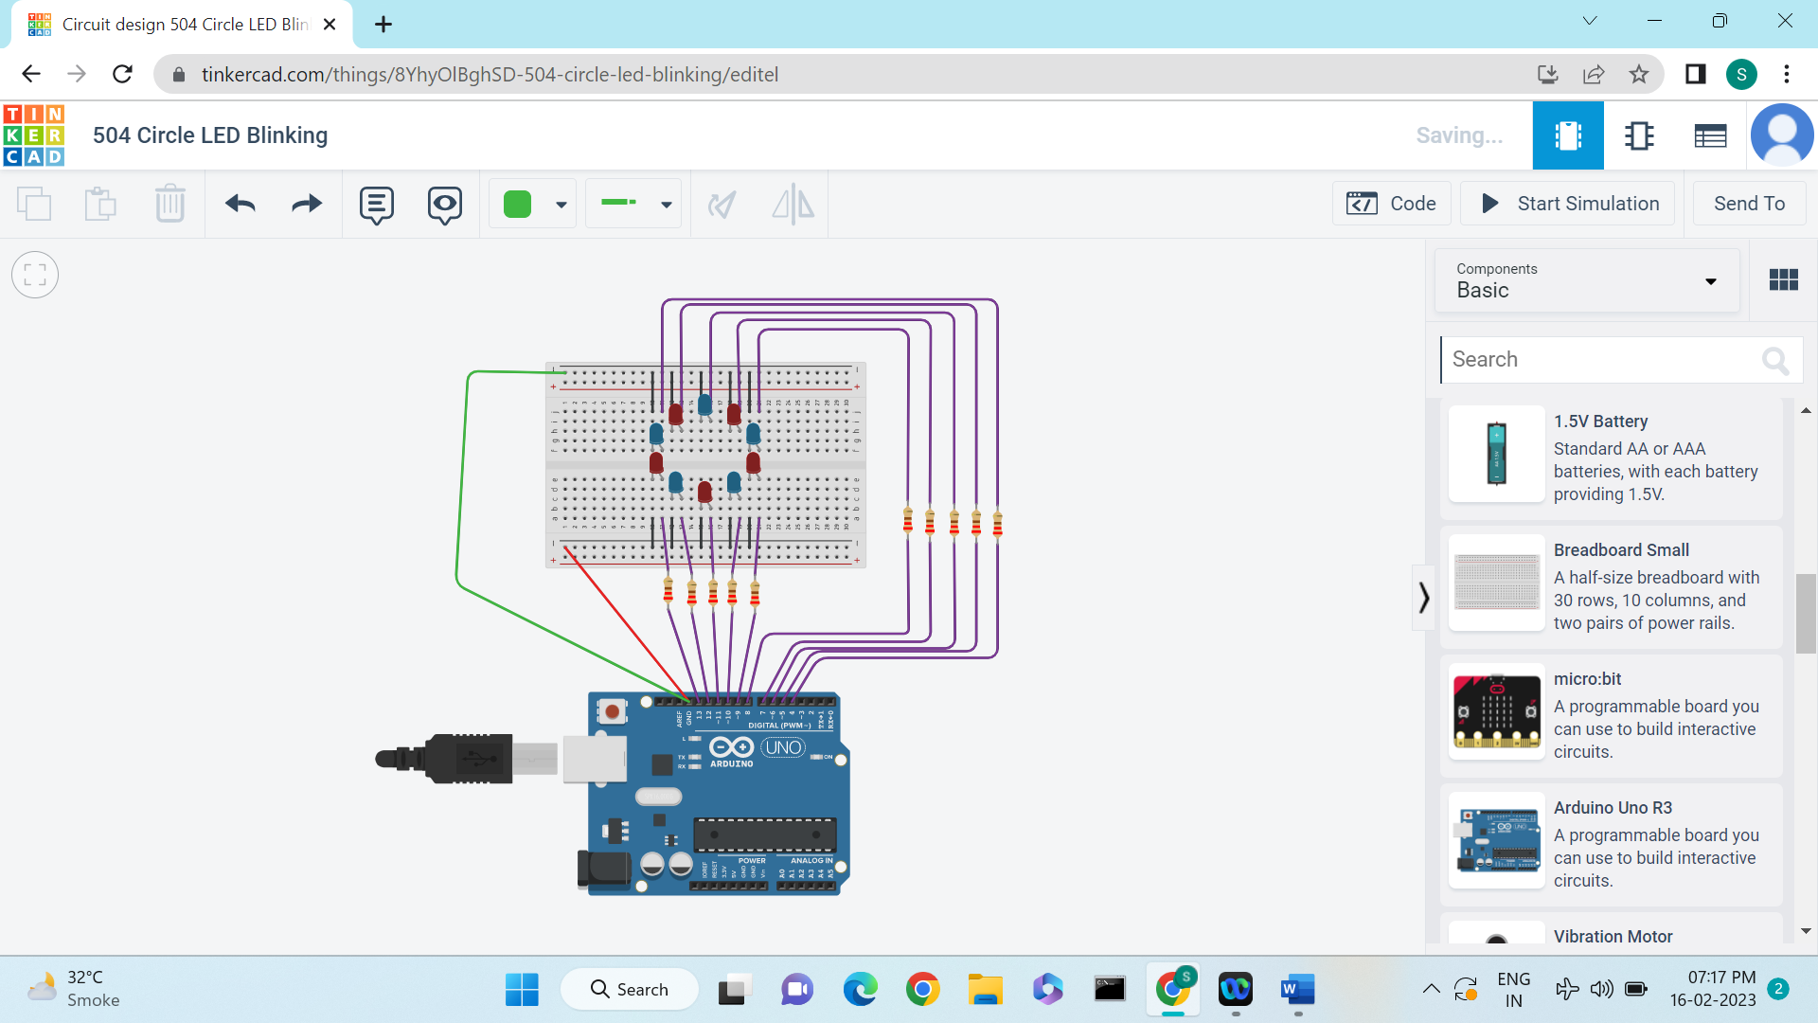

Resistor

A resistor is a passive two-terminal electrical component that **implements**electrical **resistance** as a circuit element to limit the flow of electric current. It is used in electronic circuits for voltage division, current reduction, noise suppression, and filtering.

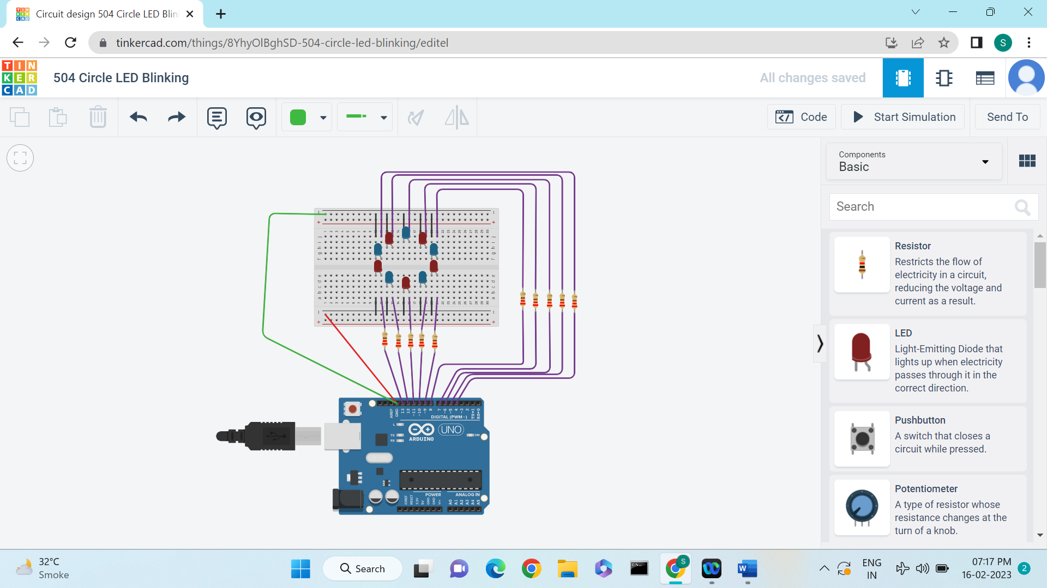

LED

LED or Light Emitting Diode is a light source device. It releases light when current passes through it. The LED concept is based on a semiconductor device where holes and electrons recombine to produce energy in the form of photons.



Arduino uno R3

The **Arduino UNO R3** is frequently used[**microcontroller board**](https://www.elprocus.com/avr-atmega8-microcontroller-architecture-applications/) in the family of an Arduino. This is the latest third version of an Arduino board and released in the year 2011. The main advantage of this board is if we make a mistake we can change the microcontroller on the board. The main features of this board mainly include, it is available in DIP (dual-inline-package), detachable and ATmega328 microcontroller. The programming of this board can easily be loaded by using an Arduino computer program. This board has huge support from the Arduino community, which will make a very simple way to start working in embedded electronics, and many more applications.

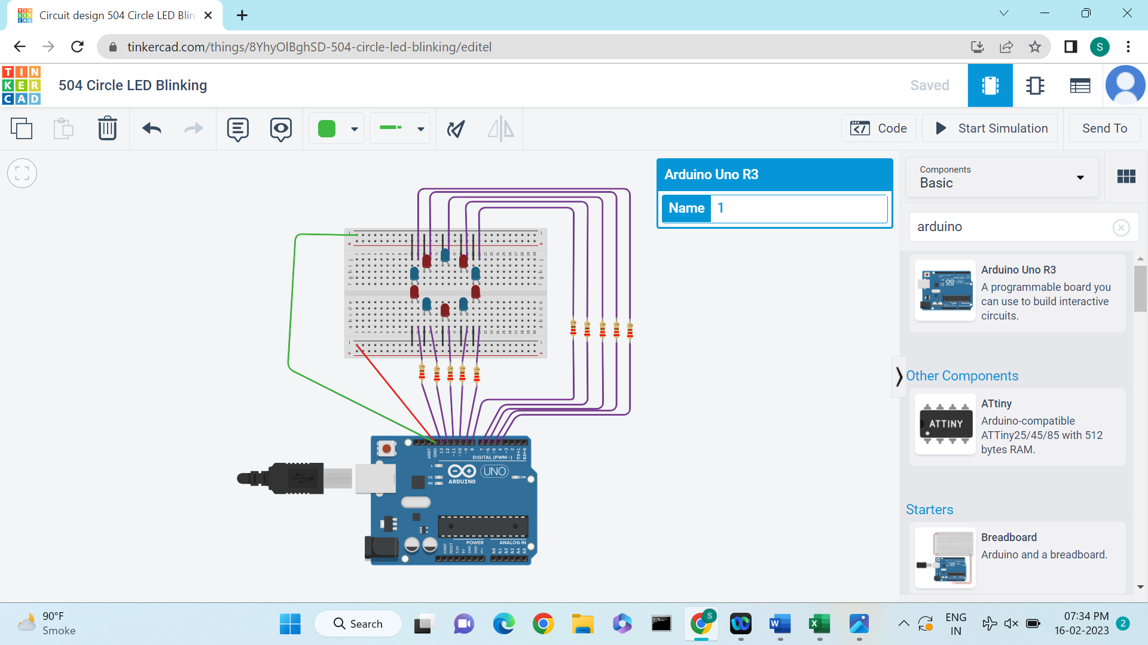

Wires ( connection )

For connections can use any wires ( only male wire is rewuired ) for electrical conductivity.

Wires can be separated according to choice of colours .

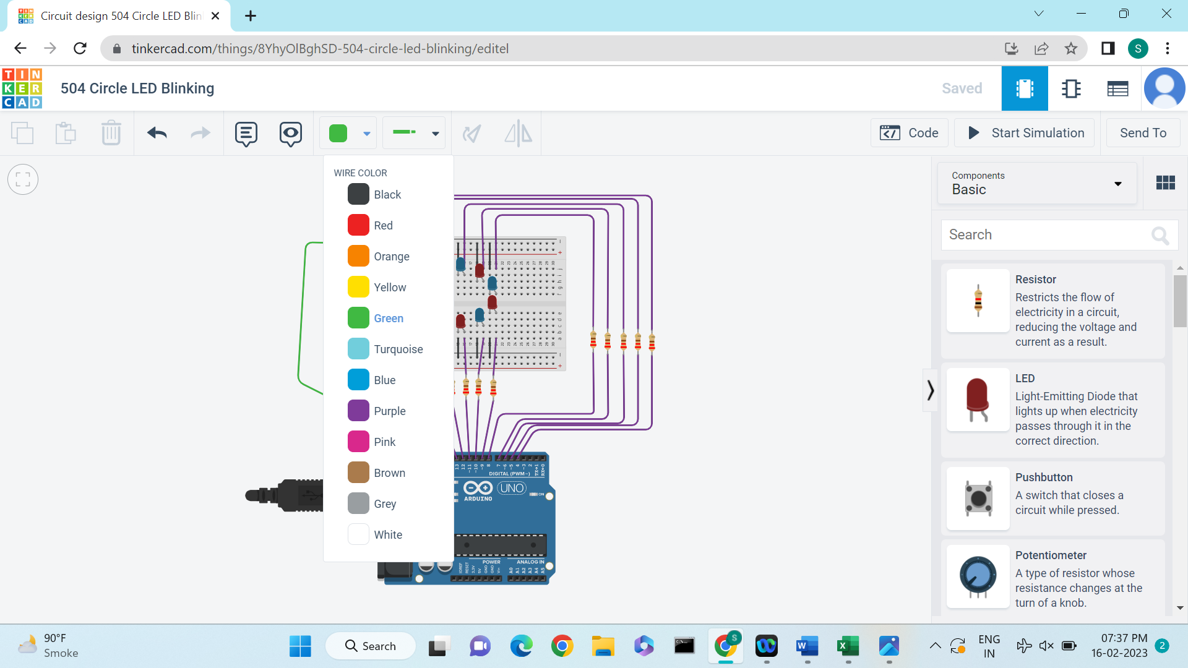

# **Componets Connectivity Table**

|  |  |  |
| --- | --- | --- |
| **Name** | **Quantity** | **Component** |
| U1 | 1 | Arduino Uno R3 |
| KEYPAD2 | 1 | Keypad 4x4 |
| R1 | 1 | 1 kΩ Resistor |
| PIEZO1 | 1 | Piezo |
| SERVO1 | 1 | Positional Micro Servo |
| D1 | 1 | White LED |

# **Source Code :**

#include <Keypad.h>

#include <Servo.h>

// Four rows

const byte ROWS = 4;

// Four columns

const byte COLS = 4;

// Define the key map

char keys[ROWS][COLS] = {

{'1', '2', '3', 'A'},

{'4', '5', '6', 'B'},

{'7', '8', '9', 'C'},

{'*', '0', '#', 'D'}

};

// Assigning pins for Rows 0 to 3

byte rowPins[ROWS] = {9,8,7,6};

// Assigning pins for Columns 0 to 3

byte colPins[COLS]= {5,4,3,2};

// define LED state

byte ledState = LOW;

Keypad keypad = Keypad(makeKeymap(keys), rowPins, colPins, ROWS, COLS); // Initialize the keypad

// Create a servo object to control the servo motor

Servo myservo;

// Initialize the servo position

int pos = 0;

void setup() {

// Set pin 13 as output to control the LED

pinMode(13, OUTPUT);

// Set pin 11 as output to control the buzzer

pinMode(11, OUTPUT);

// Attach the servo to pin 10

myservo.attach(10);

}

void loop() {

// Read the pressed key

char key = keypad.getKey();

//Code for LED

if (key == '1') {

ledState = (ledState == HIGH) ? LOW: HIGH;

digitalWrite(13, ledState);

}

//Code for buzzer

if (key == '2') {

// If key 2 is pressed, it triggers the buzzer

tone(11, 1000);

delay(100);

}

if (key=='5') {

// If key 5 is pressed, stop the buzzer

noTone(11);

}

//Code for Servo Motor

if (key == '3') {

// If key 3 is pressed, move the servo to position 180

myservo.write(180);

delay(100);

}

if (key=='6') {

// If key 6 is pressed, move the servo to rest position

myservo.write(0);

delay(100);

}

}

**OUTPUT** :

